Distribution of the ribbed mussel, *Geukensia demissa*, in the Ashley River, South Carolina

Asa Julien

Introduction

*Geukensia demissa* is a mytilid bivalve species that inhabits the salt marsh intertidal along the eastern coast of North America (Kuenzler 1961). An important ecosystem engineer in the salt marsh (Bertness 1984; Altieri *et al.* 2007; Angelini *et al.* 2015), *G. demissa* appears to exhibit different two distinct patterns of distribution depending on where it is found. In more northern sites, such as New England, *G. demissa* is most abundant at the edge of the marsh, forming a dense, continuous band (Bertness 1984; Bertness and Grosholz 1985). In the high marsh platform in these areas, which is characterized by short-form *Spartina alterniflora*, abundance is low and *G. demissa* does not exhibit clumping patterns(Bertness and Grosholz 1985). In more southern sites, however, such as the southeastern United States, *G. demissa* does not appear at the edge of the salt marsh in a continuous band, instead forming discrete, densely-settled patches in the high marsh platform and near the heads of tidal creeks (Kuenzler 1961; Stiven and Gardner 1992). The reasons for these two distinct settlement patterns are unclear, though it has been attributed to variation in predation intensity (Lin 1989; Nielsen and Franz 1995).

Many environmental variables that influence species distribution in estuaries, such as inundation period and predation, covary with elevation.Even small changes in elevation can have profound effects on the prevailing physical, chemical, and biological conditions, all of which influence species’ distributions.Establishing the exact elevational range of *G. demissa* could allow comparisons to be made among sites in different regions, and possibly lead to additional analyses, such as remote sensing and other aerial imagery-based techniques. Furthermore, there is a management need to better characterize *G. demissa* habitat in South Carolina, as a fishery for the bivalve has emerged over the past ten years.

Objectives

The purpose of this study was to characterize *G. demissa* habitat in order to better understand the variables influencing its distribution. Elevation and salinity were chosen as the primary environmental variables with which to characterize habitat. In this study, it was hypothesized that *G. demissa* would have a distinct elevational range regardless of salinity, and that this range would be confined primarily to the higher elevations in the marsh platform.

Methods

*Site selection*

The Ashley River was used to model the relationship between *G. demissa* presence-absence, elevation, and salinity. A salinity dataset established in the summer of 2015 along the Ashley River (McClellan, personal communication) was used to set up blocks of surface seawater salinity. Natural break points, such as bends in the river or physical objects such as bridges, were chosen as start and end points in order to distinguish each block along the gradient. Within each block, areas of marsh were scouted for the occurrence of *G. demissa* populations, and those containing *G. demissa* populations were surveyed. In the least saline block (5-10 ppt), however, no *G. demissa* were found during the scouting expedition. An area of marsh that was similar to habitat where *G. demissa* was found at higher salinities was chosen to be surveyed (*e.g.* high marsh with *S. alterniflora*, located near tidal creeks). The 5-10 ppt was the only block where a survey was conducted without knowing whether *G. demissa* was present beforehand.

Within each block, two surveys were conducted to establish the relationship between *G. demissa* presence and elevation. A 30-point grid consisting of five adjacent transects was superimposed over each area of marsh using ArcGIS (Version 10.3.1). Each transect began at the edge of the marsh and ran perpendicularly into the marsh interior, ensuring a range of elevations was included in each survey. Each point was scored for the presence or absence of *G. demissa* within a 1 m radius, and the elevation was recorded using an R8 trimble. The R8 system records elevation relative to the NAVD 88 tidal datum, which is based in Pointe-au-Pere, Canada. Therefore, measurements recorded by the R8 do not reflect elevation above a local tidal datum in Charleston Harbor. Efforts are currently being made to establish a local tidal datum.

*Statistics and model selection*

Logistic regression was used to model the relationship between *G. demissa* presence and elevation as well as the effects of salinity. Data were initially fit to a simple model using elevation as the only factor. This model was compared to subsequent models using likelihood ratio tests (LRTs) and Aikake information criteria (AICs). McFadden pseudo-R2 values were calculated using the *pscl* package in R (version 3.3.2). The factors included in each model, as well as their AIC scores, are listed in Table 1.

Results

The portion of the Ashley River that was surveyed for *G. demissa* is shown in Figure 1, with average summer salinities displayed at their sampling location. The river was divided into 5-ppt blocks (5-10, 10-15, 15-20, and 20-25 ppt). Within each salinity block, 80% of average monthly salinities fell within their specified range. It is important to note that these blocks only represent average summer salinities; average winter salinities may be lower than those reported in this study.

Two blocks, each consisting of two grids overlaying separate areas of marsh, were surveyed in February and March 2017 (32.80477 -79.975352; 32.813713 -79.969688; 32.832205 -80.007947; 32.827364 -80.019595). There was a significant relationship between *G. demissa* presence and elevation (logistic regression, df = 116, p < 0.01).

*Model selection*

All models used to describe the relationship between *G. demissa* presence, elevation, and salinity are displayed in Table 1. Models that used the square of elevation (elevation2) were significantly more likely (LRT, p < 0.01) than those that only used elevation, which was also reflected by their lower AIC scores. Of the models that used elevation2 as a factor, the best model included the salinity block term but not the interaction between elevation and salinity (LRT, p = 0.017). This model also had the lowest AIC (Table 1).

The best fitting model indicated that elevation had a significant effect on the probability of *G. demissa* occurrence (logistic regression, df = 116, p < 0.01), as did salinity (p = 0.022). The probability was higher in the lower salinity block (10-15 ppt). There was no interaction between salinity and elevation; the elevational range of *G. demissa* remained constant across the two salinity blocks. Figure 2 shows the relationship between *G. demissa* presence and elevation; the red and black lines represent the output from the elevation2 + block model.

Table 1. Description of models used for *Geukensia demissa* distribution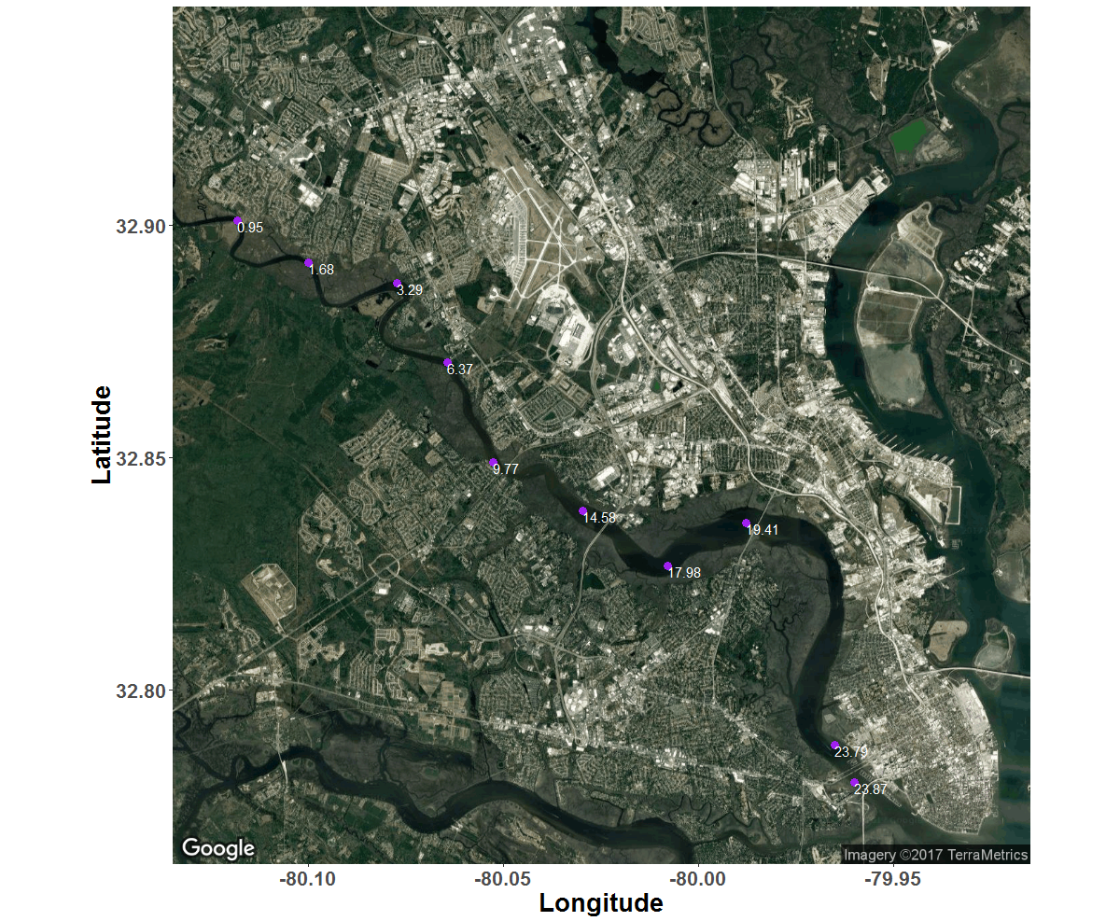

Figure 1. Average salinities (ppt) along the Ashley River, calculated from May - September 2015.

|  |  |  |  |
| --- | --- | --- | --- |
| Model | Factors | AIC | Pseudo R2 |
| 1 | Elevation, elevation2, block | 125.5 | 0.24 |
| 2 | Elevation, elevation2, block, elevation2 *x* block | 127.4 | 0.24 |
| 3 | Elevation, elevation2 | 129.21 | 0.2 |
| 4 | Elevation | 141.75 | 0.11 |
| 5 | Elevation, block | 140.86 | 0.12 |
| 6 | Elevation, block, elevation *x* block | 142.78 | 0.13 |

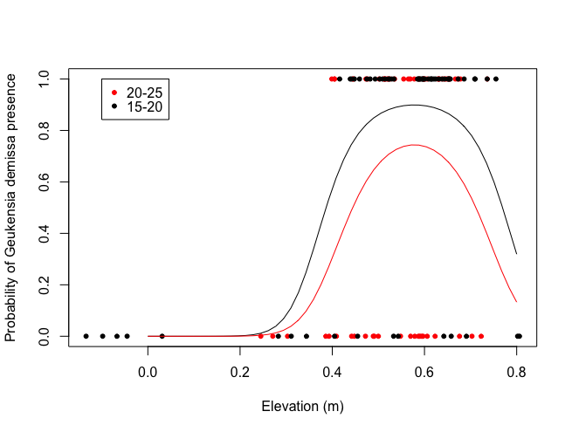

Figure 2. The relationship between the probability of *G. demissa* occurrence and elevation (m) within two different salinity regimes (ppt). Lines represent values predicted by the most likely model. Red indicates the higher salinity block (20-25 ppt), while black indicates the lower salinity block (15-20 ppt). N = 120.

References

Altieri, A.H., B.R. Silliman, and M.D. Bertness. 2007. Hierarchical organization via a facilitation cascade in intertidal cordgrass bed communities. *The American Naturalist* 169:195-206.

Angelini, C., T. Heide, J.N. Griffin, J.P. Morton, M. Derksen-Hooijberg, L.P.M. Lamers, A.J.P. Smolders, and B.R. Silliman. 2015. Foundation species’ overlap enhances biodiversity and multifunctionality from the patch to landscape scale in southeastern United States salt marshes. *Proceedings of the Royal Society of London B* 282:20150421.

Bertness, M.D. 1984. Ribbed mussels and *Spartina alterniflora* production in a New England salt marsh. *Ecology* 65:1794-1807.

Bertness, M.D., and E. Grosholz. 1985. Population dynamics of the ribbed mussel, *Geukensia demissa*: The costs and benefits of an aggregated distribution. *Oecologia* 67:192-204.

Kuenzler, E.J. 1961. Structure and energy flow of a mussel population in a Georgia salt marsh. *Limnology and Oceanography* 6: 191-204.

Stiven, A.E., and S.A. Gardner. 1992. Population processes in the ribbed mussel *Geukensia demissa* (Dillwyn) in a North Carolina salt marsh tidal gradient: spatial pattern, predation, growth and mortality. *Journal of Experimental Marine Biology and Ecology* 160:81-102.

Lin, J.L. 1989. Influence of location in a salt marsh on survivorship of ribbed mussels. *Marine Ecology Progress Series* 56:105-110.

Nielsen, K.J. and D.R. Franz. 1995. The influence of adult conspecifics and shore level on recruitment of the ribbed mussel *Geukensia demissa* (Dillwyn). *Journal of Experimental Marine Biology and Ecology* 188:89-98.